TRES ESTUDIOS

MIRAR PASIVAMENTE:

<https://www.realeye.io/es/item/9b1e1ed2-4c03-432d-aceb-3bc7cc32c37d/#itemId=9b1e1ed2-4c03-432d-aceb-3bc7cc32c37d&participantId=all&viewType=fixations&heatmapType=heatmap&fineTunePointSize=&fineTuneShadow=&fineTuneOpacity=&itemTimeFrom=0&itemTimeTo=19200&tags=&exposureNumber=&keys=&genderMale=true&genderFemale=true&genderOther=true&genderNotSpecified=true&ageMin=0&ageMax=99&participantTypeRealEye=true&participantTypeOwn=true&participantQualityGradeItemMin=1&participantQualityGradeItemMax=6&movingMedianRangeMs=200&minFixationDurationMs=80&maxFixationDurationMs=400&gazeVelocityThreshold=150&maxSaccadeDurationMs=150>

ATENDER ROSTROS:

<https://www.realeye.io/es/item/b8bcb961-e6f0-4cee-8662-d63293fe16dd/#itemId=b8bcb961-e6f0-4cee-8662-d63293fe16dd&participantId=all&viewType=fixations&heatmapType=heatmap&fineTunePointSize=&fineTuneShadow=&fineTuneOpacity=&itemTimeFrom=0&itemTimeTo=2600&tags=&exposureNumber=&keys=&genderMale=true&genderFemale=true&genderOther=true&genderNotSpecified=true&ageMin=0&ageMax=99&participantTypeRealEye=true&participantTypeOwn=true&participantQualityGradeItemMin=1&participantQualityGradeItemMax=6&movingMedianRangeMs=200&minFixationDurationMs=80&maxFixationDurationMs=400&gazeVelocityThreshold=150&maxSaccadeDurationMs=150>

ATENDER ESCENAS:

<https://www.realeye.io/es/item/435c086a-da88-44db-a650-86fd915b8245/#itemId=435c086a-da88-44db-a650-86fd915b8245&participantId=all&viewType=fixations&heatmapType=heatmap&fineTunePointSize=&fineTuneShadow=&fineTuneOpacity=&itemTimeFrom=0&itemTimeTo=3700&tags=&exposureNumber=&keys=&genderMale=true&genderFemale=true&genderOther=true&genderNotSpecified=true&ageMin=0&ageMax=99&participantTypeRealEye=true&participantTypeOwn=true&participantQualityGradeItemMin=1&participantQualityGradeItemMax=6&movingMedianRangeMs=200&minFixationDurationMs=80&maxFixationDurationMs=400&gazeVelocityThreshold=150&maxSaccadeDurationMs=150>

MIRAR PASIVAMENTE:

ATENDER ROSTROS:

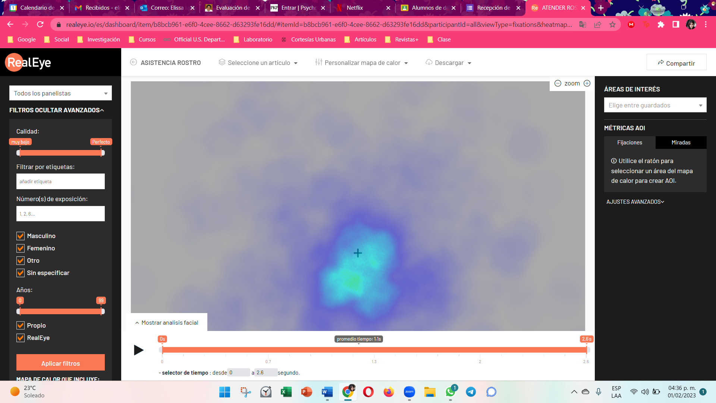

ATENDER ESCENAS:

